## Charging stations on highways

|  |
| --- |
| **No. Highways/Expressways Charging Stations**  1 Mumbai - Pune Expressway 10  2 Surat-Mumbai Expressway 30  3 Mumbai - Delhi Highway 124  4 Mumbai - Panaji Highway 60  5 Mumbai - Nagpur Highway 70  6 Mumbai - Bengaluru Highway 100  7 Agra-Nagpur 80  8 Kolkata- Nagpur 120  9 Chennai- Nagpur 114  **Total**  708 |

*The data contains all type of vehicles, but here we are focussing on only the following types:*

* BUS
* E-RICKSHAW(P)
* M-CYCLE/SCOOTER
* M-CYCLE/SCOOTER-WITH SIDE CAR
* MOPED
* MOTOR CAB
* MOTOR CAR
* OMNI BUS
* THREE WHEELER (GOODS)
* THREE WHEELER (PASSENGER)
* THREE WHEELER (PERSONAL)
* E-RICKSHAW WITH CART (G)

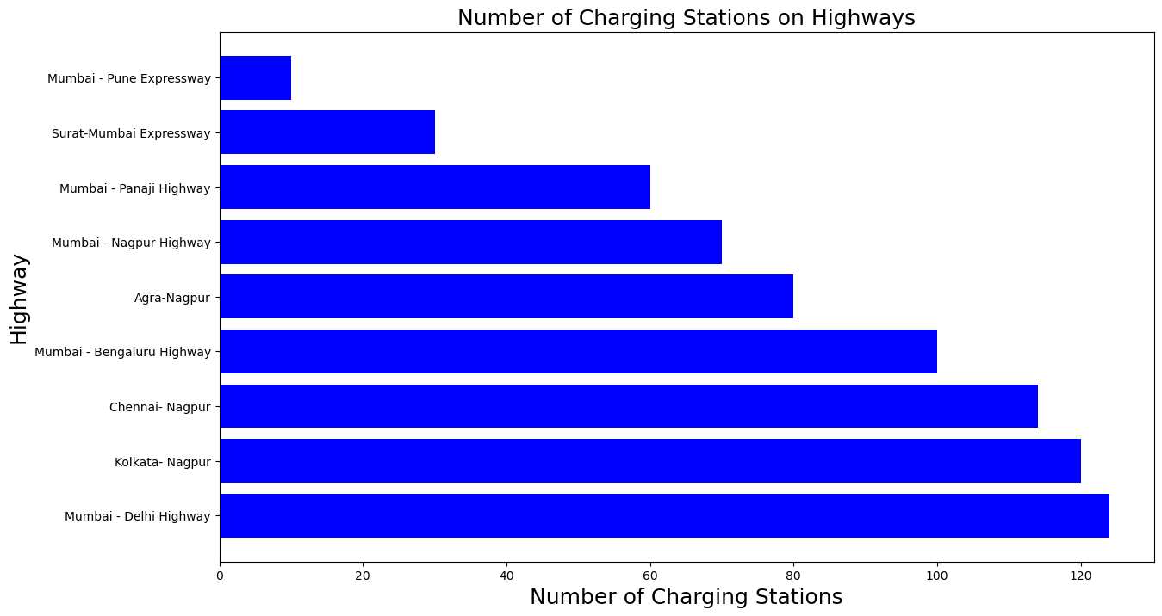

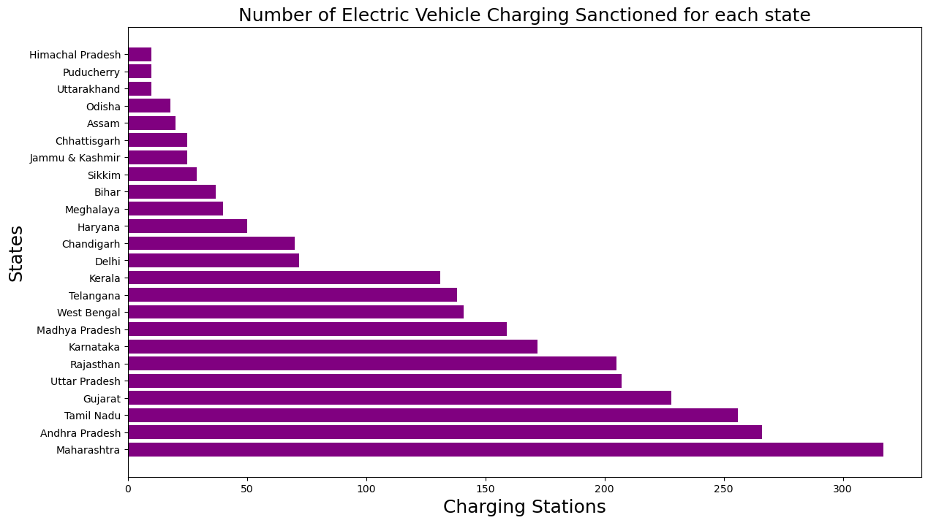

**States to target based on charging stations sanctioned**

* Maharashtra
* Andhra Pradesh
* Tamil Nadu
* Gujarat
* Uttar Pradesh
* Rajasthan
* Karnataka

# Integrating data for EV of all states:

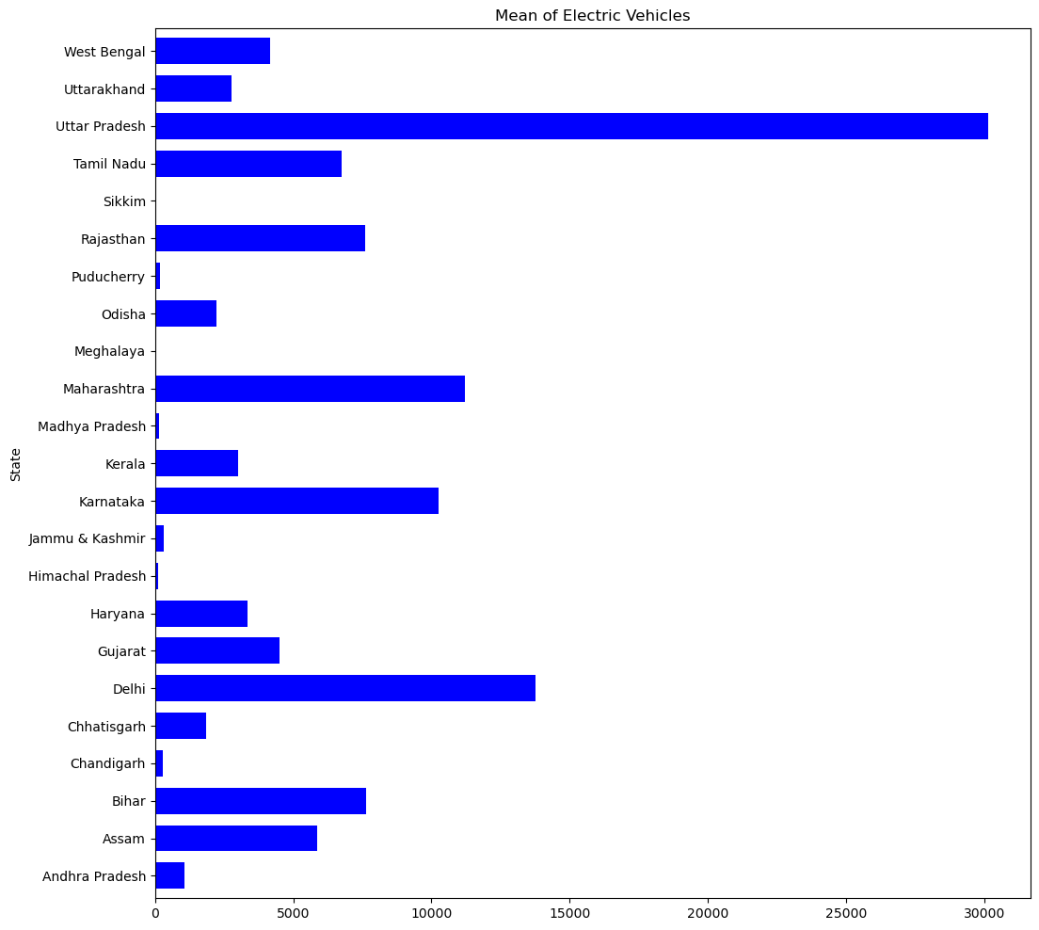

**States to target :**

* Maharashtra
* Uttar Pradesh
* Karnataka
* Gujarat
* Delhi
* Rajasthan
* Haryana

# Visualizing the fuel types used for each vehicle class & identifying vehicle categories utilizing Battery Electric Vehicle (BEV) technology.

## Maharashtra

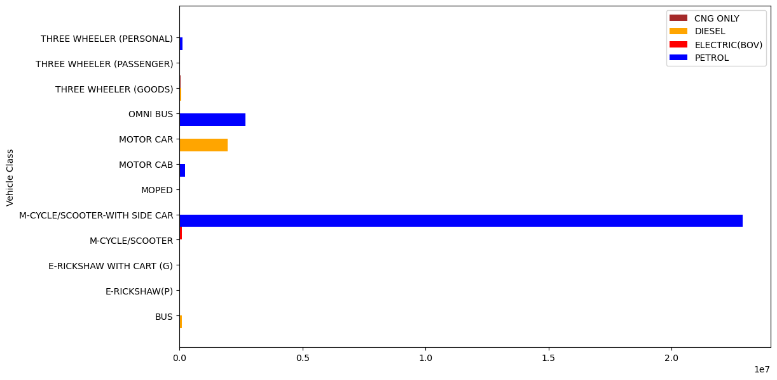

* The visualization displays the utilization of different fuel types across various vehicle classes.

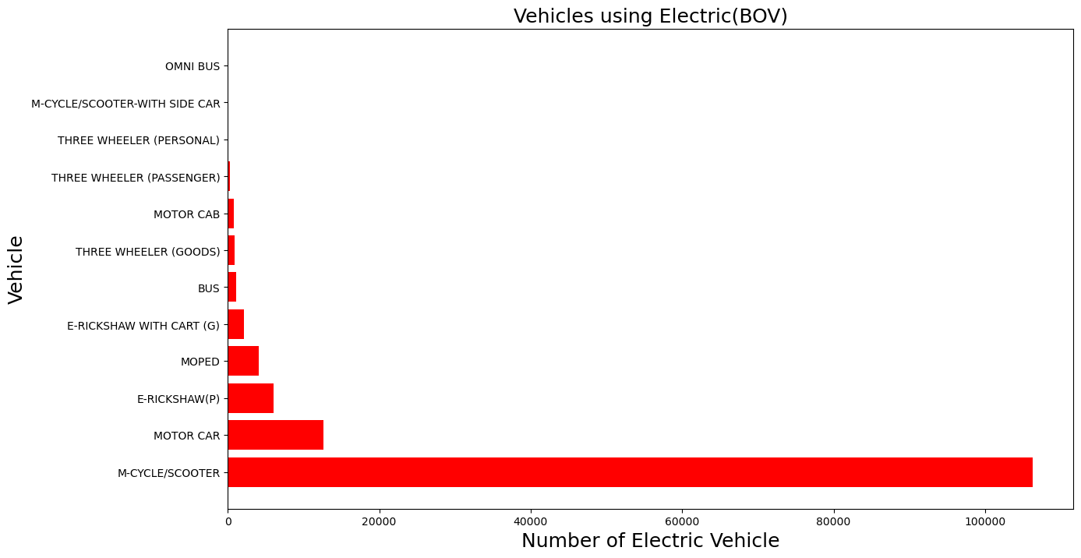

* The visualization highlights specific vehicle categories within the Maharashtra state that present opportunities for targeting Battery Electric Vehicles (BEVs).

## Uttar Pradesh:

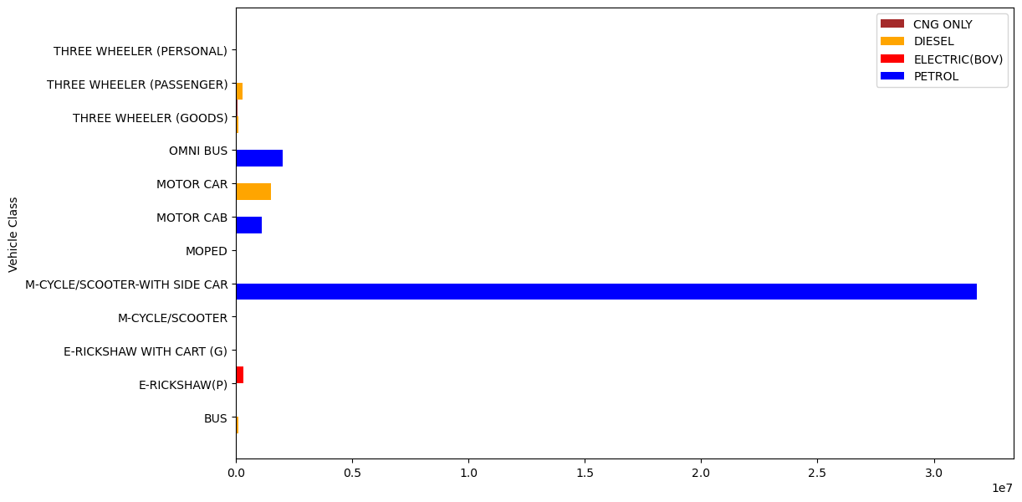

* This plot explains utilisation of different fuels in the state UP

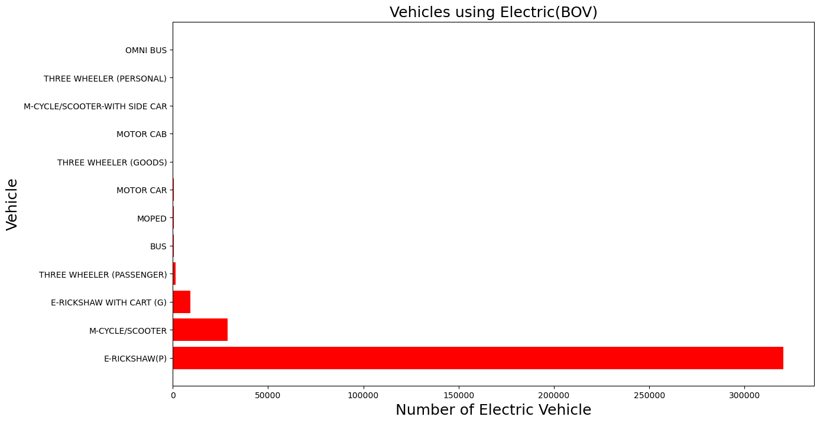

* This plot illustrates the potential opportunities within the Electric Vehicle (EV) market in Uttar Pradesh (UP).

## Delhi

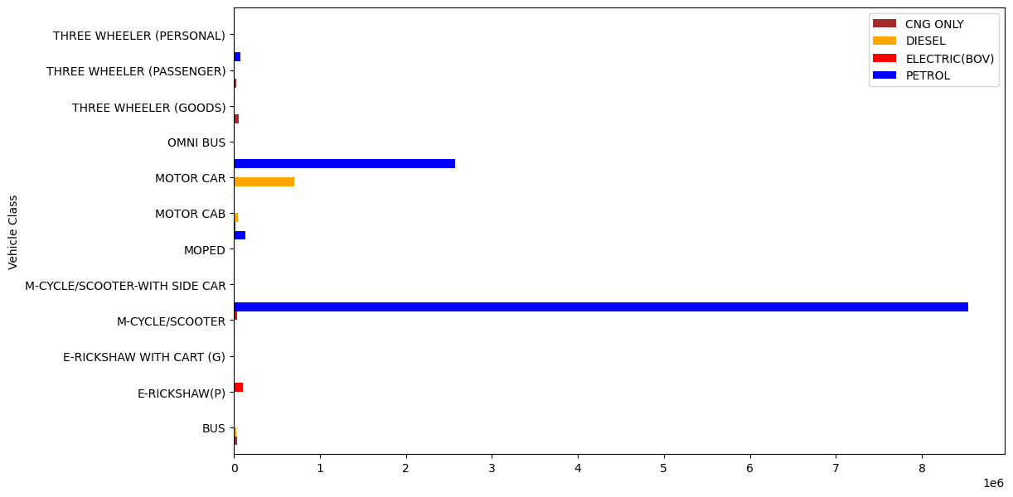

* This plot explains utilisation of different fuels in the state Delhi

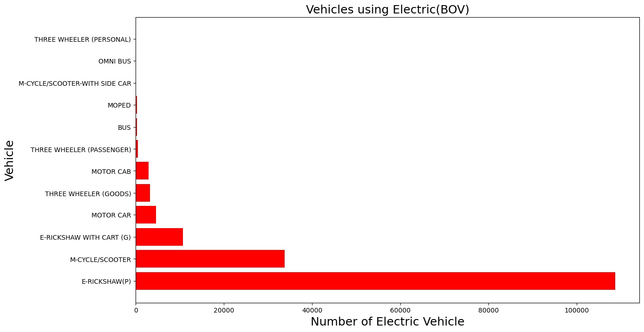

* This plot illustrates the potential opportunities within the Electric Vehicle (EV) market in Delhi.

## Karnataka

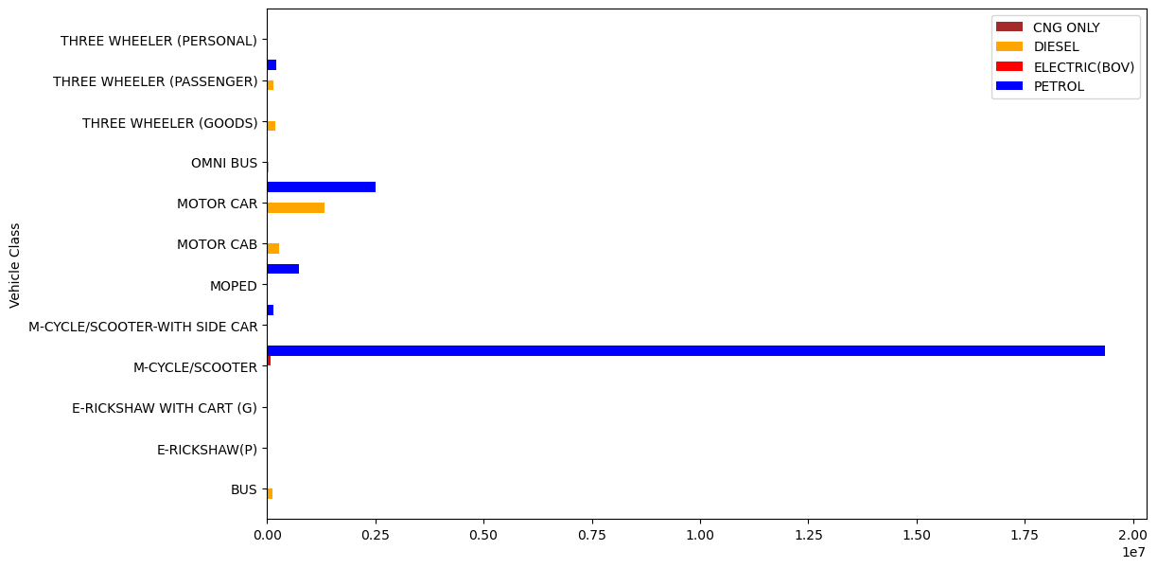

* This plot explains utilisation of different fuels in the state Karnataka

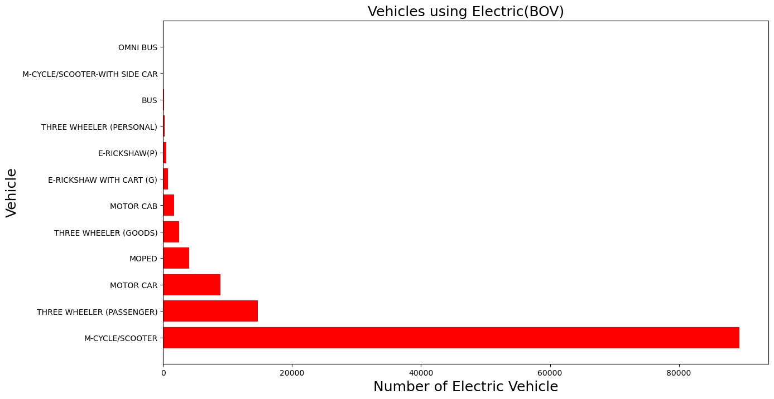

* This plot illustrates the potential opportunities within the Electric Vehicle (EV) market in Karnataka.

## Gujarat

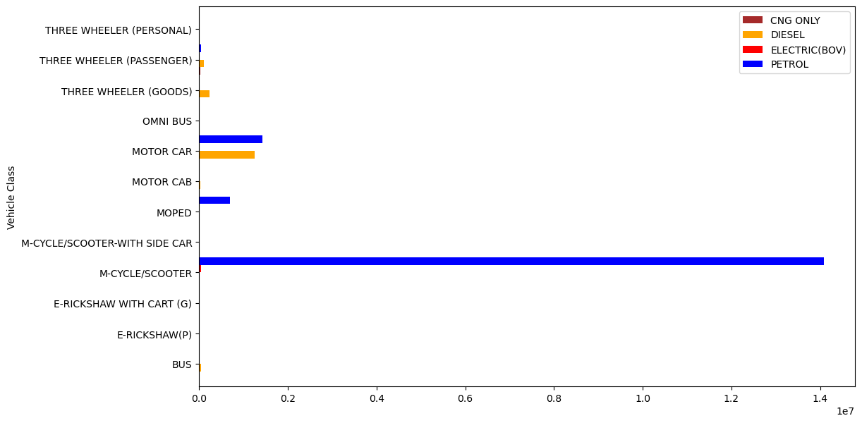

* This plot explains utilisation of different fuels in the state Gujarat

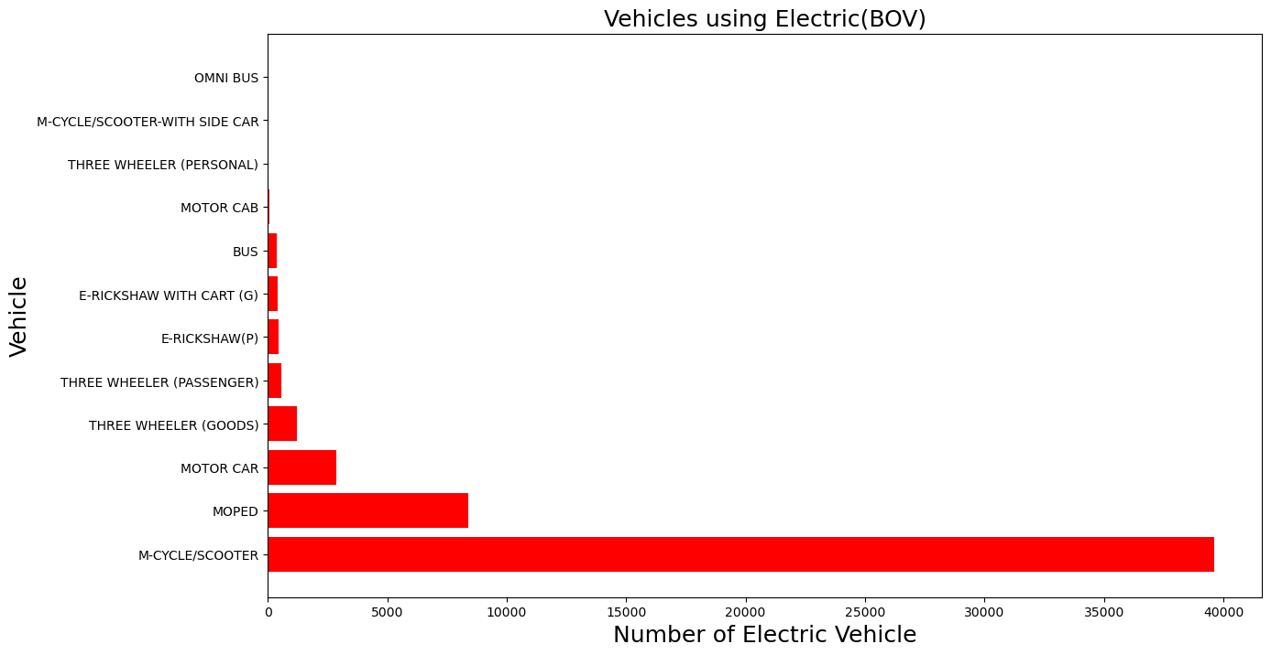

* This plot illustrates the potential opportunities within the Electric Vehicle (EV) market in Gujarat.

## Rajasthan

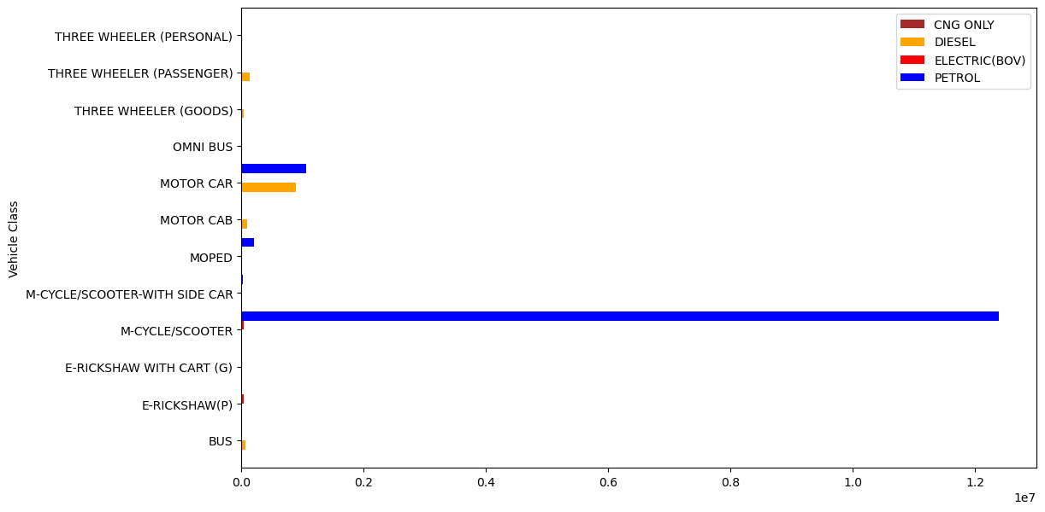

* This plot explains utilisation of different fuels in the state Rajasthan

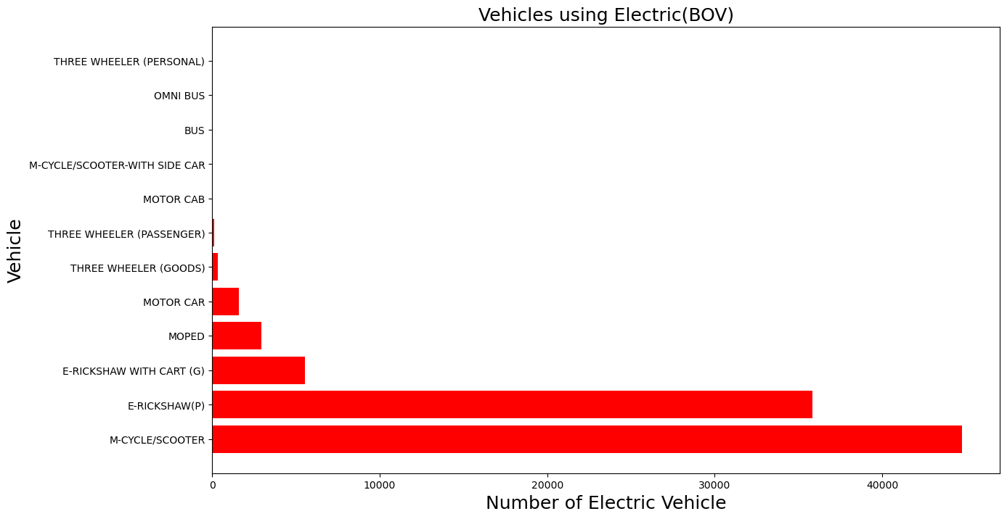

* This plot illustrates the potential opportunities within the Electric Vehicle (EV) market in Rajasthan.

## Haryana

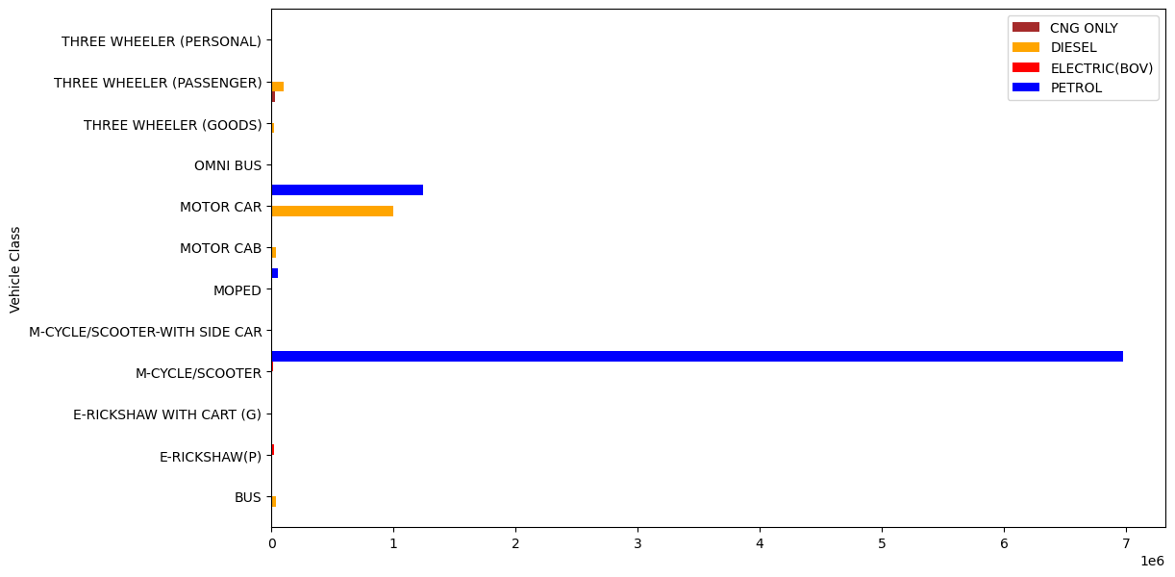

* This plot explains utilisation of different fuels in the state Haryana

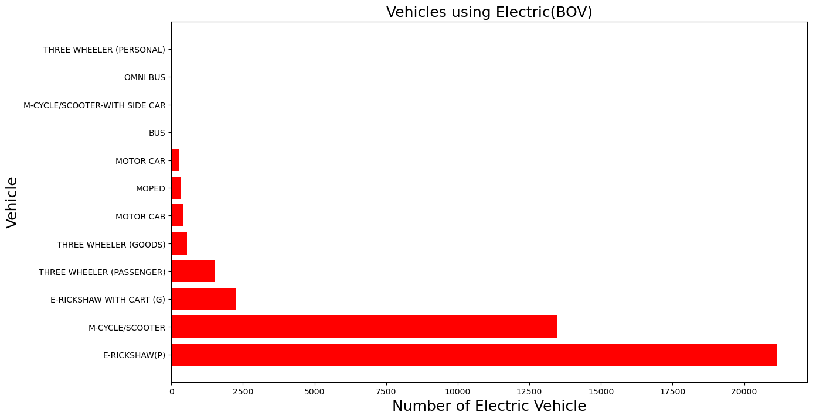

* This plot illustrates the potential opportunities within the Electric Vehicle (EV) market in Haryana.